Languages Spoken in Oregon

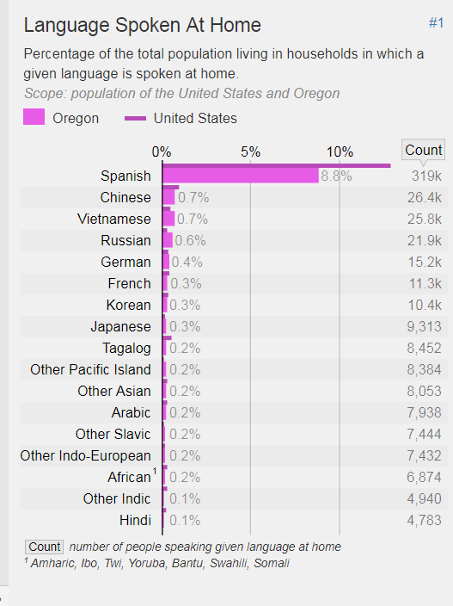

As of 2015. Source: Retrieved from https://statisticalatlas.com/state/Oregon/Languages#figure/language-spoken-at-home

