Plank House (Lower Columbia)
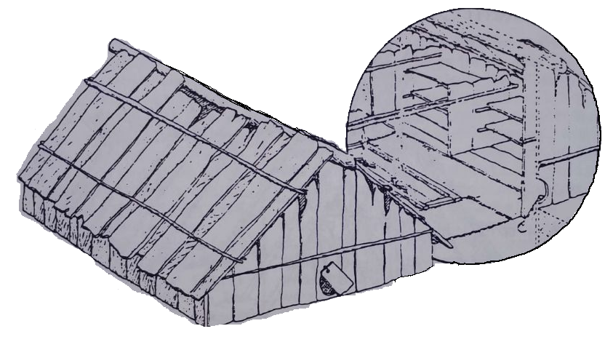

LOWER COLUMBIA AREA TRIBES
The Lower Columbia Area is in northwest Oregon. It includes the lower parts of the Columbia and Willamette rivers. These rivers were filled with a lot of salmon. The fish were important to Indians. Indians traveled the rivers to trade resources with each other. Some of the main features of the area were its rapids, waterfalls, and a large island. The rapids and waterfalls were used as fishing spots. These spots marked the boundaries between some Indian tribes. In the east, Fivemile Rapids was near The Dalles. In the south, there was Oregon Falls, near Oregon City. Sauvie Island contained many roots and plants that could be eaten. The Lower Columbia Area had a lot of people living in the area. It was the most densely populated section of Oregon with about 400 people living in each square mile. Tribes lived in plank houses, and they used long-prowed canoes for travel.
The people of the Lower Columbia Area are commonly called Chinook Indians. They were divided into a few different tribes and bands. This included the Clatsop, Cathlamet, Skilloot, and other tribes. Chinook was a common trade language the tribes spoke. The tribes had different dialects and some differences in their culture. Each tribe included several bands. The Chinook people had large, permanent, independent villages. Villages were strongly connected to each other by trade and marriages.
Long-Prowed Canoe
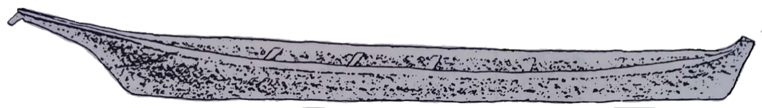
The Chinooks lived on both sides of the Columbia River (modern day Oregon and Washington). The river was a highway for travel and not seen as a barrier. Washington groups, such as the Shoalwater Chinook and the Wishart, worked closely with their Oregon neighbors.
There was a lot in common among the Chinooks, but there were also differences. The Wasco Wishram were farther east near The Dalles. They lived in a different location and were many miles from the Chinook tribes who lived closer to the Columbia River. They spoke different dialects of the Chinookan language family.
All the people in this area shared fishing as a way of life. Their Chinookan culture also included an emphasis on trade and rank. Politically and socially, however, the people belonged to many separate tribes. Today, some of the descendants of these tribes have confederated into one and call themselves the Chinook Indian Nation.
Plank House (Northern Coast)
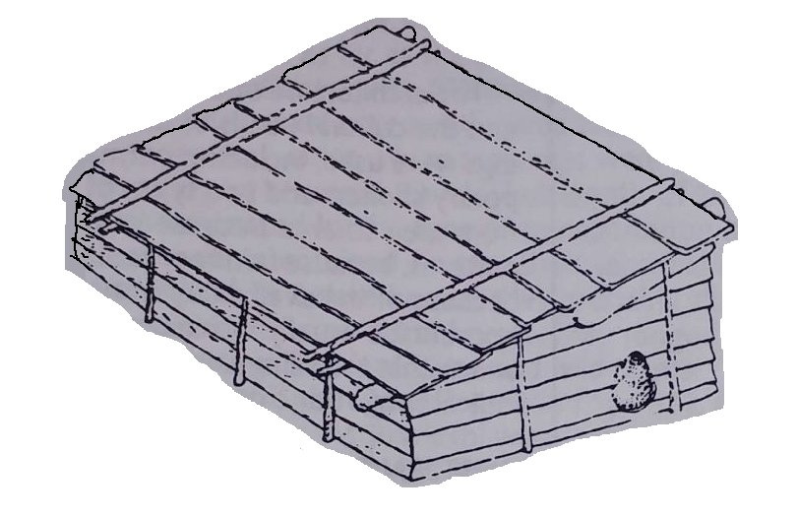

COAST AREA TRIBES
The Coast Area includes the lower parts of some larger rivers (i.e., the Rogue, Umpqua, Coquille and Nehalem rivers) and all the smaller coastal rivers. The tribes in this area had the Pacific Ocean as a boundary on the west. The mountains of the Coast Range were to the east. This area had two major resources: salmon in the rivers and seafood along the coast. The Coast Range provided hunting areas and berries. The mountains made it difficult for coastal and inland tribes to interact. At the southern part of the Coast Area, the Coast Range joins the Siskiyou Mountains and Klamath Highlands. Borders between tribes were not hard and fast. The Coast Area was heavily populated with about 150 people living in each square mile. The Indians here lived in plank houses and used canoes for travel.
The people in the Coast Area belonged to many different tribes and spoke many different languages. They lived in large, permanent villages. Their villages were in clusters along the rivers. It was easier to use the rivers for travel. Because of this, the people along each river system developed a local dialect and shared customs.

Plank House (Southern Coast)
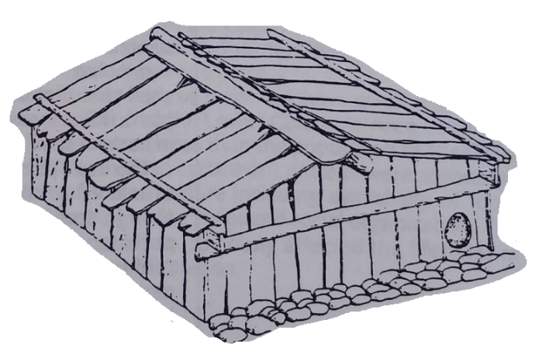
The tribes in the northern part of the Coast Area were known collectively as the Tillamook. They spoke related dialects. The Siletz spoke a different dialect. Sometimes the Siletz were referred to as a band of the Tillamook. The Yaquina, Alsea, Siuslaw, and Lower Umpqua tribes occupied the central coast. Each of these tribes had a group of related villages along major rivers. The Hanis Coos and Miluk Coos lived in large villages along the shores of Coos Bay. The Hanis Coos and Miluk Coos spoke related languages.
The tribal divisions south of Coos Bay were not as clear. There were many villages and bands that spoke Athapascan languages. Each village was somewhat independent, and villages were not solely part of one tribe or another. For example, the Tututni included a few divergent bands and villages. The southernmost tribes on the coast – the Tolowa and Chetco – extended into modern-day California.

INLAND VALLEYS AREA TRIBES
Bark-and-Brush Plank House
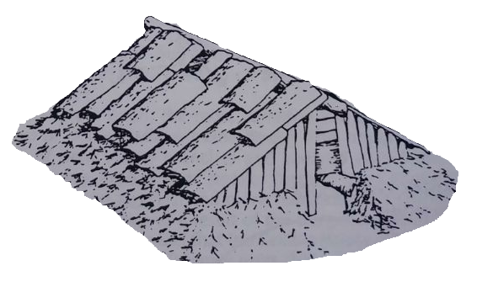
The Inland Valley is a large and diverse area. It includes the upper parts of the Willamette, Rogue, Umpqua, Coquille, and Nehalem rivers. The best fishing on these rivers was where the rivers reached the Coast and Lower Columbia tribes. Salmon was available for some, but not all, people of the Inland Valleys Area. The Inland Valley tribes relied on nuts, root vegetables, hunting, and berry picking. These were plentiful. The large valleys along the Willamette and Rogue Rivers provided a large variety of natural resources. The smaller valleys along the Cascade and Siskiyou mountain slopes had fewer resources. The tribes in this area lived in bark-and-brush plank houses. People traveled by foot and canoe. The population was low compared to the coast and lower Columbia with about 50 people living in each square mile.
The Inland Valleys had perhaps the most diverse tribal organization in Oregon. Villages were often smaller. People did not always live permanently in a village like the tribes on the Coast and Lower Columbia. Individuals or families could easily change allegiance from one village to another.
In the north, the Clatskanie tribe spoke Athapascan and had a unique culture along the upper Nehalem and Clatskanie rivers. They were closely related to the Washington Calhoun tribe.
Tribes and bands that lived along the Willamette River's central valley and the lower parts of its tributary spoke Kalapuyan languages. Other tribes were farther south. For example, the Yoncalla Kalapuyans lived along part of the Umpqua River. Each of the Kalapuyan groups was made up of smaller bands that were semi-nomadic. They had many differences in dialects and culture. The Cow Creek tribe lived in the Inland Valley near the South Umpqua River. They spoke Takelma, which was related to other Kalapuyan languages.

Twined Berry Basket
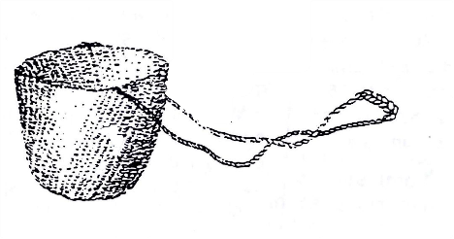
The bands of the Molalla tribe lived along the western slopes of the Cascade mountains. Their territory was between the Clackamas and Rogue Rivers. The Molalla roamed as far east as the Deschutes River in their seasonal food gathering rounds.
Many tribes that spoke Athapascan also lived in the Inland Valleys of southwestern Oregon. This included the Upper Umpqua, the Upper Coquille, and the Shasta Costa. The Takelma and their upland relatives, the Latgawa, lived along parts of Rogue River. Two Athapascan tribes – the Galice Creek and Applegate Creek – lived along smaller rivers within Takelma territory. Two Californian tribes – the Shasta and the Karok – used some land near the modern border of southern Oregon.

KLAMATH LAKES AREA TRIBES
Shovel-Nose Canoe
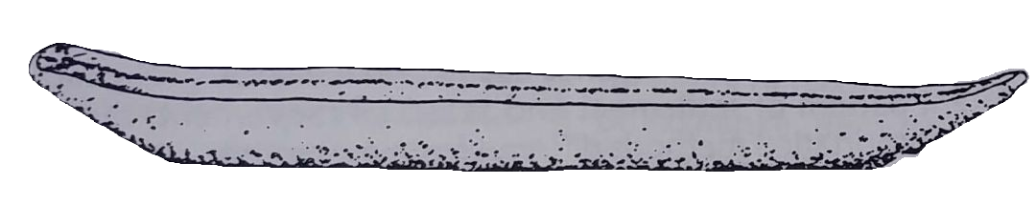
The major features of this area of south central Oregon are the Klamath lakes and the marsh lands around them. Upper and Lower Klamath lakes, Tule Lake and Agency Lake supplied lots of food sources, mostly plants and waterfowl. The rivers draining into these lakes had good fishing. Klamath and Sycan marshes were lush hunting and gathering spots. Farther to the west, the Cascade Mountains were also good sites for hunting and berry picking.
Earth-Covered Lodge
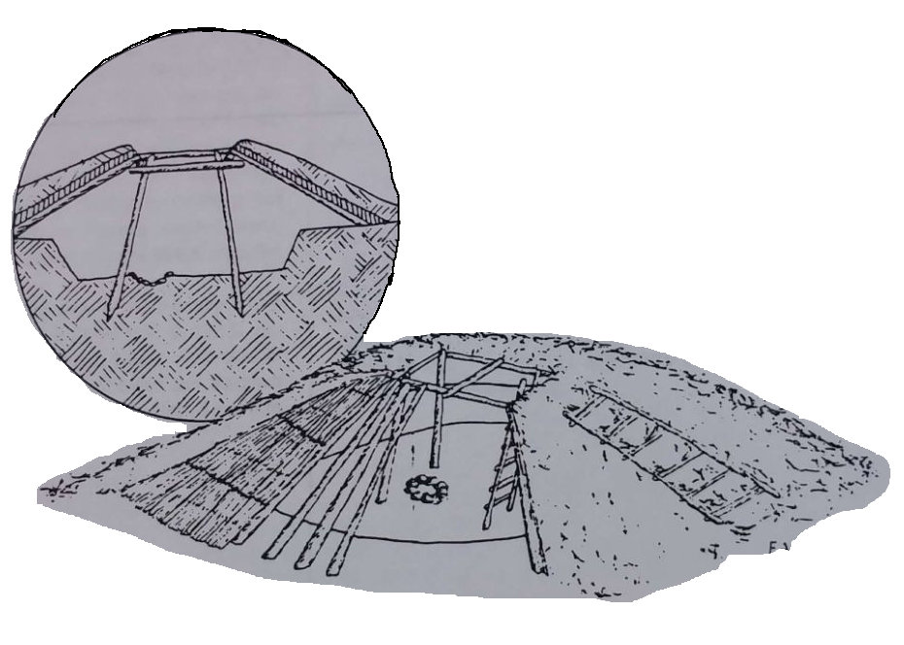
The people of this area built a culture that was centered around being close to lakes and marshes. Population was lower than the lands to the west, with about 10 people living in each square mile. They lived in homes in the winter time, called lodges, that were covered with earth. They also used shovel-nose canoes when they needed to travel.
Two major tribes lived in this area, the Klamath and the Modoc. The two tribes had some things in common, like their language and parts of their culture, but also had other important differences too. Two Modoc bands lived in Oregon along Lost River. Most of the Modoc Indians lived in California, close to Tule Lake. Several bands of the Klamath lived around Klamath Lake and near what is now the city of Klamath Falls. Another large group lived near Klamath Marsh and others lived near Agency Lake, along the Williamson River and in the hill country near the town of Bly. A third tribe, the Achomawi, lived in California but sometimes came in to the Klamath lands.

Fishing Platform
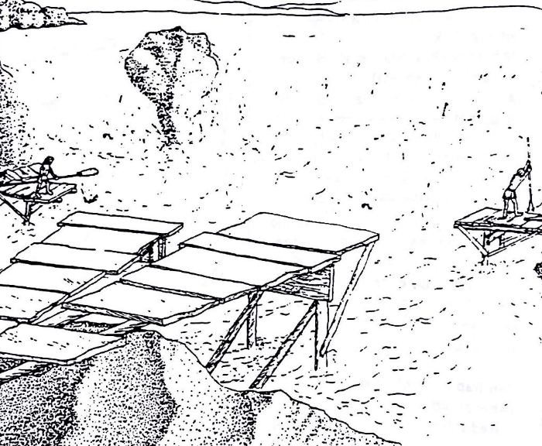

COLUMBIA PLATEAU AREA TRIBES
The Columbia Plateau Area includes a part of the upper Columbia River and a few smaller rivers (Deschutes, John Day, Umatilla, Grande Ronde). The best fishing was located at a place called Celio Falls on the Columbia River and the rivers near the Lower Columbia and Coast. The area had plants that could be eaten and good hunting, maybe better than any other part of Oregon.
The people that lived in this area were very different from tribes in western Oregon. In winter time, they lived in mat longhouses. Population was lower than the lands to the west, with about 10 people living in each square mile. When they needed to travel, it was by foot or canoe until much later when horses were brought to the area.
The Nez Perce lived in two groups, one in Oregon and one in Idaho. In Oregon, the Joseph and lmnaha bands lived in the Wallowa Mountains.
Mat Longhouse
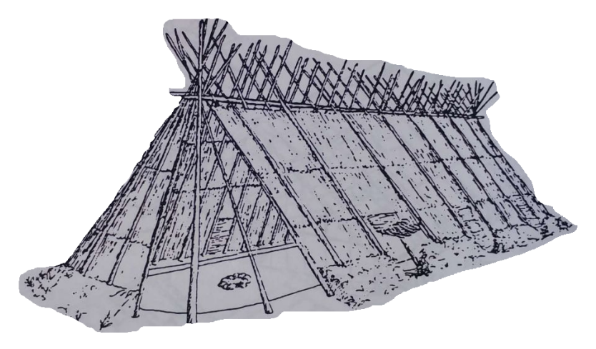
The Cayuse lived in an area stretching from Washington to the Blue Mountains. They probably also lived in bands, but little is known about that today.
The Umatilla and Walla-Walla spoke a language similar to what was used by the Nez Perce and Warm Springs bands in Oregon. The Walla-Walla lived mostly in southeastern Washington, while the Umatilla lived in the area near Arlington east to the Umatilla River.
Along the lower John Day and Deschutes rivers and in the Celilo Falls area of the Columbia lived four bands called the Tenino, the Wyam, the John Day and the Tygh. They spoke the same language, with some differences, and shared some customs in everyday life. They did like to keep their independence from one another though. In treaty times, settlers lumped them all together, calling them Walla-Walla or Warm Springs. Today the four bands are known as either the Warm Springs, the Wayampam, or the Tenino.

GREAT BASIN AREA TRIBES
Willow-Frame House
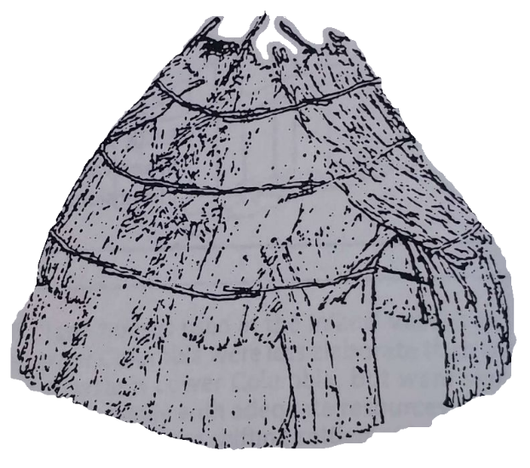
This large area, with few major rivers, held different foods for the tribes. Although some fishing was done on the Snake River and along several smaller rivers, fish were not as important as other foods. Lakes (including Malheur, Harney, Silver, Goose, and Warner) were also a source of plants and birds. The slopes of Steen, Hart, and other mountains were important sources for roots and seed plants that the people could eat.
Great Basin peoples had the lowest population of any area in Oregon, with about 5 people living in each square mile. The people here lived in small camps, wintered in willow-frame houses and walked where they needed to go until horses were introduced in the mid-1800s. In some cases, they used boats made of tule (a type of reed) as a temporary type of canoe.
All of the bands in this area spoke the Paiute language and parts of their culture were also alike. The Great Basin Area had a lot of natural resources, and each Paiute band built their lives to best match the location of where they lived. The Paiutes were called Snake Indians by settlers, a confusing term because relatives of the Paiutes-the Shoshone, Bannock, and Southern Paiute of Idaho, Nevada, and California-were also called Snakes.
The only permanent social unit were the groups that families would join while searching for food in the area. Families would also form temporary winter camps, but it was common for them to change from year to year. These groups of people who shared a way of gathering food, and those who lived in one area often named themselves after a food source. The Wadadika of Harney Basin for example, were named after the Wada plant whose seeds were an important food source near Harney and Malheur lakes.
The Paiute band structure helped the tribe to not overuse any resource. A drought or famine in one area could be avoided by moving to a new area and joining another band.
Tule Boat
