Mountain with a Hole in the Top
The Cow Creek Umpqua Tribe tells a tale from long ago about the animal-people and the man-people. This shortened version of the story was told by Ellen Crispen, a Cow Creek descendant.
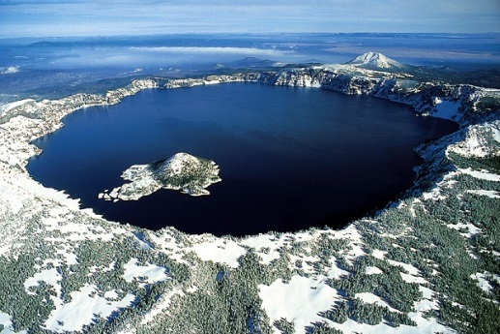
A very long time ago, the animal-people and the man-people shared the same language. They lived in the shadow of a snow-capped mountain. The bear, deer, panther, and elk shared the mountain area with the man-people, and they lived in peace. An evil chief arose among the man-people, and he believed he was greater than Old Man God. He turned the man-people against the animal-people. He ordered them to kill the animal-people. The chief of the animal-people sought the guidance of their god, Tamanous, who told them to flee. The wildcat remained behind because he wanted to become chief of the animal-people after Chief Bear left. Man-chief was told that all the animals had fled. He went outside and saw wildcat. He decided he did not like wildcat and picked him up and burned off his tail.
Tamanous was very angry that wildcat was hurt. Suddenly, he caused a great wind to blow from the top of the mountain. Trees fell, and man could not breathe the hot wind. Black smoke rolled over the mountain top. Fire came out of the top. The mountain flew into the air, and then landed down on the earth with a sound like thunder that shook everything. The mountain no longer had a top. The man-people were all dead. Over time, water filled the great hole in the top. Tamanous decided to put the souls of the man-people in the big water hole at the top of the mountain. The animal-people eventually returned, but they could no longer speak the same language as the man-people. Old Man God told the man-people to never return to the hole on the top of the mountain.

An oral retelling of this story is provided in the folder of curricular materials provided by the tribe.

