# **Languages Spoken in Oregon**[1]

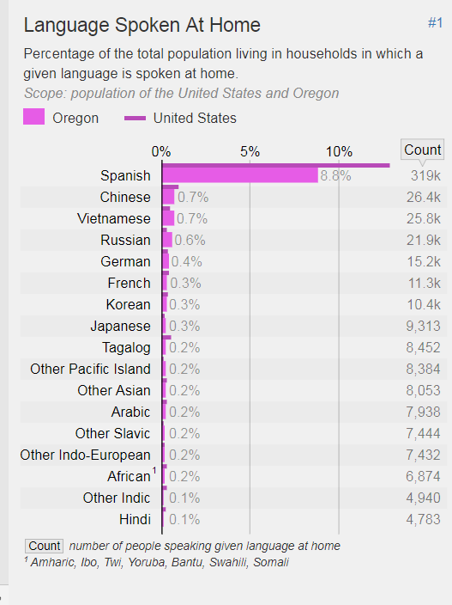

1. As of 2015. Source: Retrieved from <https://statisticalatlas.com/state/Oregon/Languages#figure/language-spoken-at-home>